Criteria 4
4.2.1 LIST OF FACILITIES FOR PATIENT CARE TEACHING LEARNING PROCESS
During the training period of BHMS students the students are being trained to take care of the patients by learning the following procedure which helps the patients to fell at home. Procedure that is done during the care of client in the hospital is has to be done in the skillful way.
Objectives of teaching learning process at the bed side of client:-
- Define teaching learning and teaching learning process
- Identify principles of effective education
- Identify teaching learning aspects
- Recognize teaching learning system
- Discuss educational spiral.
1. Admission procedure:- During the admission the patient and the family member are at panic stage and not able to take proper decision which create obstacle in care of patient. The students gives the orientation about the treatment procedure as well as about the environment.
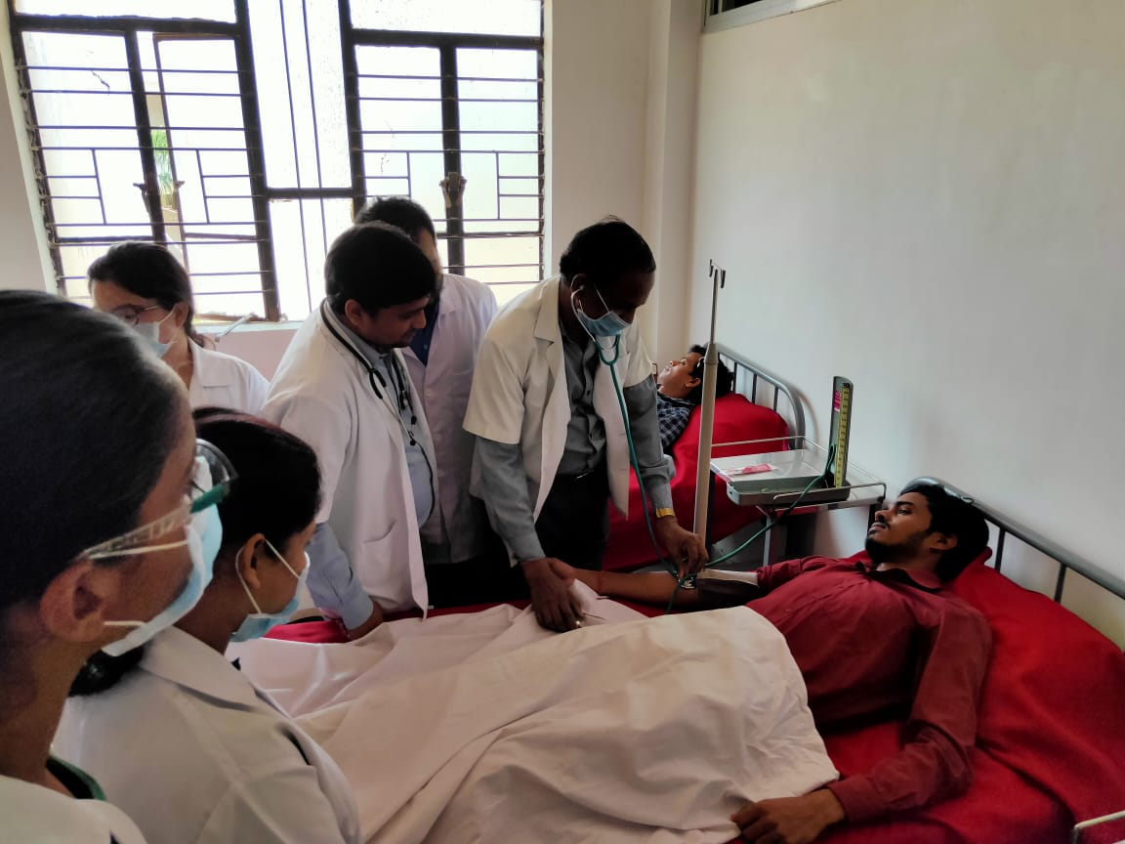
2. Taking vital signs:- Taking vital signs are the procedure which gives baseline data about the client. Students are being taught to take vital signs and to maintain rapport with the patient.
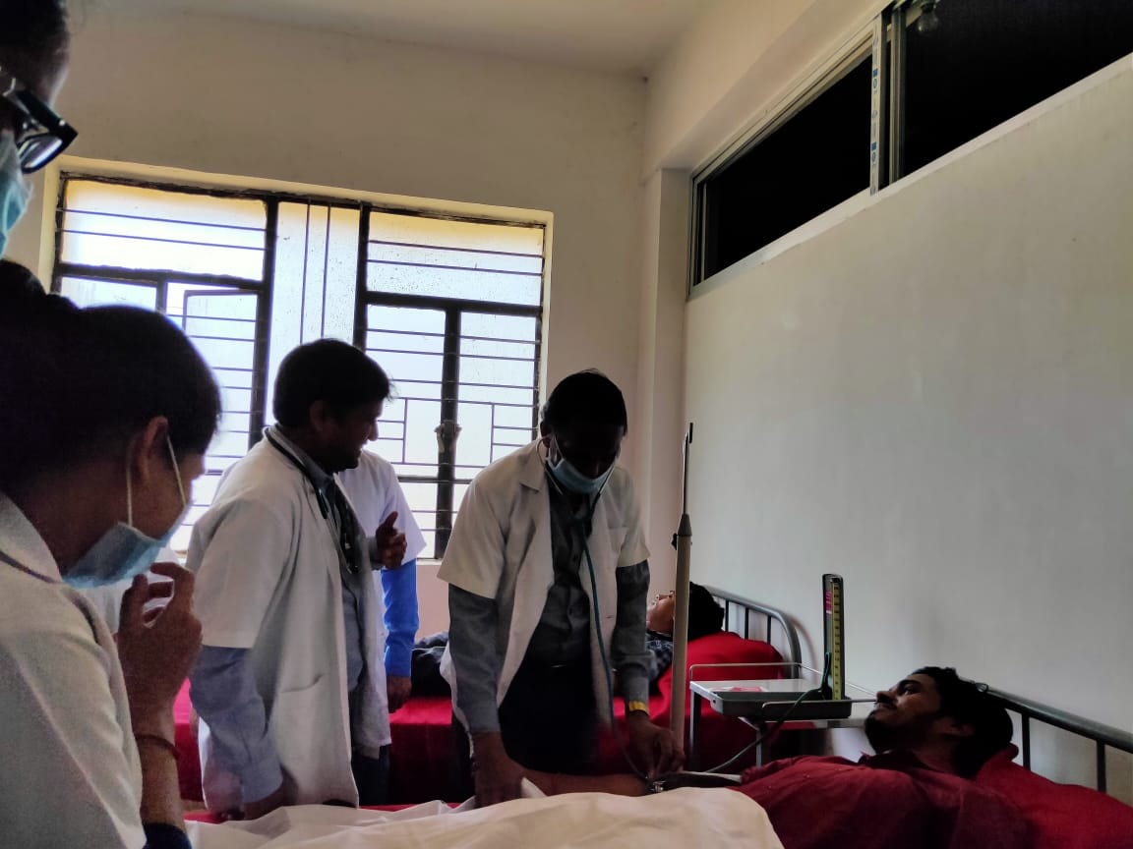
3. Administration of medication :- Giving medication is the main function of the health care personnel. The half disease is being cured by the behavior of the health care personnel. Administration of right medicine to the right patient at right time is very much important in medical profession. The students are being taught about the action, dose and route of drug administration.
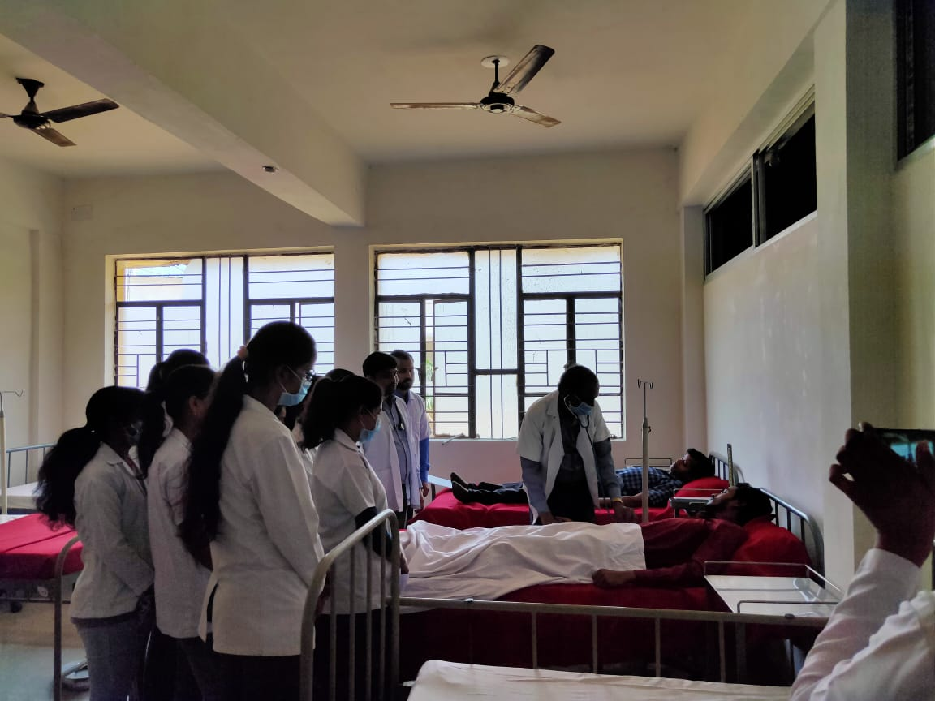
4. Physical assessment:- Is consists the through and keen observation of the client by the health care personnel and by the medical students. During the admission the students are being taught about to do physical assessment which helps to correlate the subjective data with objective data.
5. Antenatal examination:- During the pregnancy period the students observe the pregnant women and learn about the various changes which occur during pregnancy. They also learn about the embryology and fetal growth. According to the condition of mother during pregnancy they give health education to the mother and family.
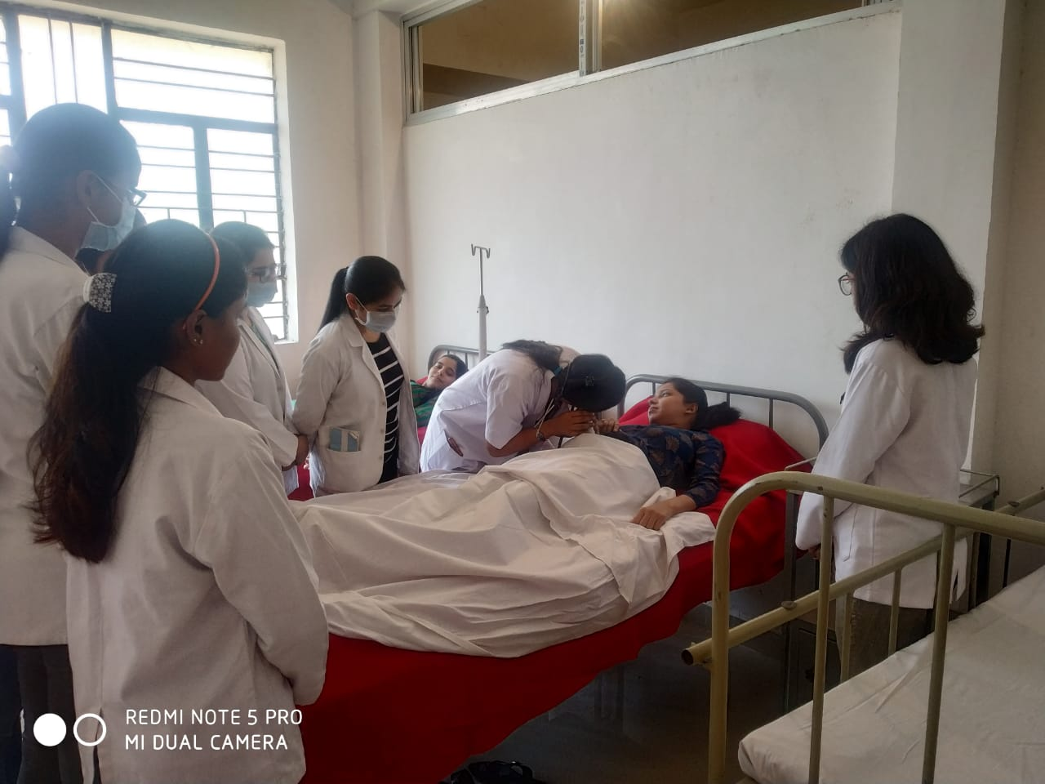

The other procedures are as follow:-
- Collection of specimen
- General examination
- Respiratory examination
- Neurological assessment
- Antenatal examination
- Process of taking case study and care plan.
Taking case study and maintaining case record:-By this method students gets opportunity to care for the client with all the information of the client which help them to correlate the theory knowledge with the practical knowledge. This taking case study and maintaining case record develops the skill among the students and help them to maintain the inter personal relationship with the patients.
The case was divided into acute and chronic cases and students are asked to take thecases as it is given into syllabus .

